SQL Project
SQL String & Pattern Matching
Author: Kamlesh Kumar Jha
Date: 29 August 2026
This project demonstrates SQL string functions and pattern-matching techniques used to filter and search text fields, applied to a sample Employees table.

Project Overview
This project explores how SQL can be used to search, filter, and match text data using string functions and pattern-matching operators. Working with a small Employees table, each task below tackles a common real-world text-search requirement — such as matching an email domain, checking the first or last letters of a name, or performing a case-insensitive search — and compares two different SQL approaches for solving it.
Key Concepts Covered
- LIKE operator and wildcard patterns (%, _)
- String functions: LEFT, RIGHT, SUBSTRING, LEN
- CHARINDEX for substring position search
- Case-insensitive matching using LOWER() and COLLATE
- Comparing multiple valid approaches for the same problem and choosing the most efficient one

Task 1: Create and Populate the Table
The first step sets up the working dataset. An Employees table is created with four columns — EmpID, Name, Department, and Email — and five sample rows are inserted so that every later query has real data to run against.
Step 1: Drop the table if it already exists
DROP TABLE IF EXISTS Employees;
This safety check removes any previous version of the table so the script can be re-run cleanly without a "table already exists" error.
Step 2: Create the table
CREATE TABLE Employees (
EmpID INT PRIMARY KEY,
Name VARCHAR(50),
Department VARCHAR(50),
Email VARCHAR(50)
);
EmpID is defined as the PRIMARY KEY, meaning each employee record must have a unique, non-null identifier. The remaining columns store descriptive text data about each employee.
Step 3: Insert sample data
INSERT INTO Employees (EmpID, Name, Department, Email) VALUES
(1, 'Alice Johnson', 'HR', 'alice.johnson@example.com'),
(2, 'Bob Smith', 'IT', 'bob.smith@example.com'),
(3, 'Charlie Brown', 'Finance', 'charlie.brown@example.com'),
(4, 'Diana Prince', 'HR', 'diana.prince@example.com'),
(5, 'Eve Adams', 'IT', 'eve.adams@example.org');
Five employees are inserted across three departments (HR, IT, Finance), with mostly matching email domains but one deliberate exception (Eve Adams uses .org instead of .com) — this makes the domain-matching query in Task 2(a) meaningful, since it should exclude that row.

Task 2: String & Pattern Matching Queries
Each part below solves one text-search requirement using two different SQL techniques, followed by a short comparison of which is generally the better choice.

(a) Employees with @example.com Emails
Goal: List employees whose email address belongs to the example.com domain.
Method 1 — LIKE
SELECT Name, Email
FROM Employees
WHERE Email LIKE '%@example.com';
The % wildcard matches any characters before "@example.com", so this returns every row whose email ends exactly with that domain string. It is simple and readable, but a stray match could theoretically occur if the domain text appeared elsewhere in a malformed address.
Method 2 — RIGHT + LEN
SELECT Name, Email
FROM Employees
WHERE RIGHT(Email, LEN('@example.com')) = '@example.com';
RIGHT(Email, LEN('@example.com')) extracts exactly the last 13 characters of each email and compares them directly to the target string. This guarantees an exact suffix match with no ambiguity.
✔ Recommended: RIGHT + LEN is more precise and efficient for exact domain matching in production systems.
Output: screenshot_2a:
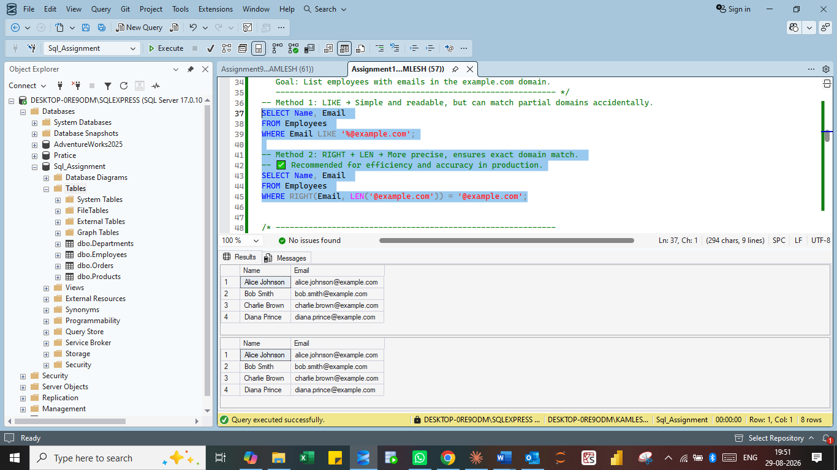

(b) Names Starting with 'A'
Goal: Select employees whose first name begins with the letter A.
Method 1 — LIKE
SELECT Name
FROM Employees
WHERE Name LIKE 'A%';
The pattern 'A%' matches any string starting with 'A' followed by zero or more characters. It's the most common and easy-to-read way to check a prefix.
Method 2 — LEFT
SELECT Name
FROM Employees
WHERE LEFT(Name,1) = 'A';
LEFT(Name,1) extracts just the first character of each name and compares it to 'A'. Because it only inspects a fixed position, it can be marginally faster than a wildcard scan.
✔ Recommended: LEFT is a good choice when checking a fixed starting position, such as the first letter.
Output: screenshot_2b:
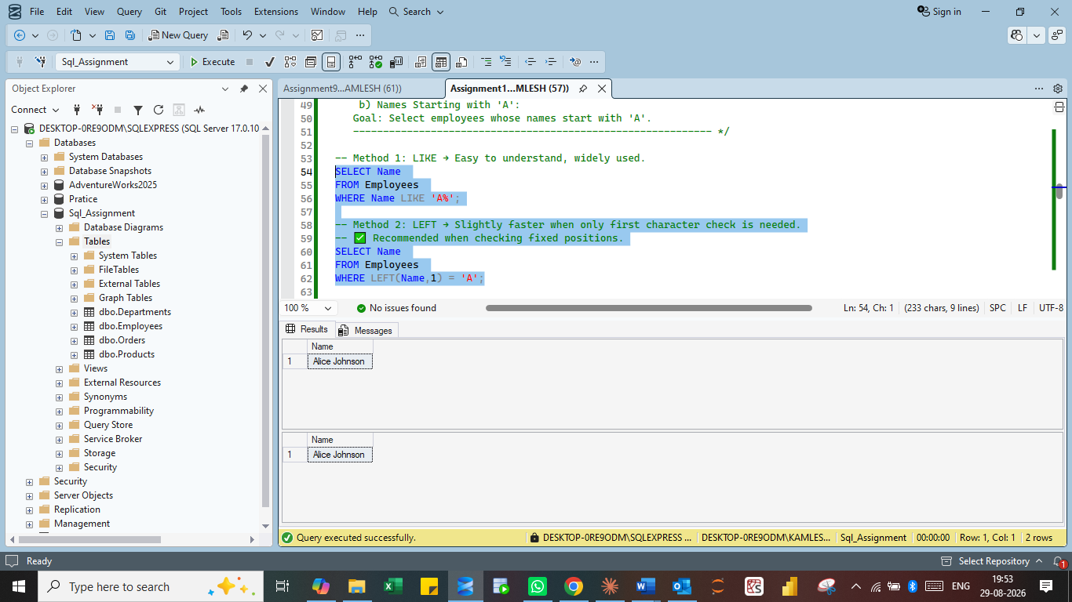

(c) Names Ending with 'son'
Goal: Find employees whose name ends with the suffix "son".
Method 1 — LIKE
SELECT Name
FROM Employees
WHERE Name LIKE '%son';
The pattern '%son' matches any string ending in "son", regardless of how many characters come before it — flexible for suffixes of varying length.
Method 2 — RIGHT
SELECT Name
FROM Employees
WHERE RIGHT(Name,3) = 'son';
RIGHT(Name,3) pulls the last three characters of each name and compares them to 'son' directly, which is efficient when the suffix length is known in advance.
✔ Recommended: RIGHT is preferable when the suffix length is fixed and known.
Output: screenshot_2c:
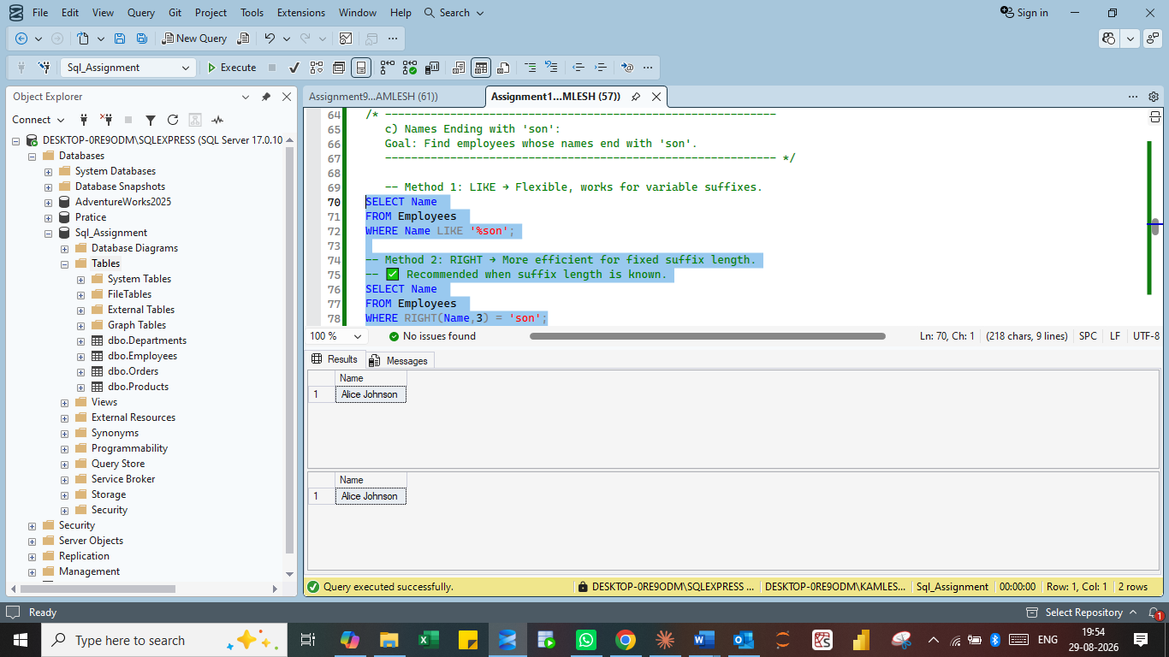

(d) Second Letter is 'v'
Goal: Retrieve employees whose second character in their name is 'v'.
Method 1 — SUBSTRING
SELECT *
FROM Employees
WHERE SUBSTRING(Name,2,1) = 'v';
SUBSTRING(Name,2,1) extracts exactly one character starting at position 2 and compares it to 'v'. This approach is explicit and works for checking any character position, not just the second.
Method 2 — LIKE with '_' wildcard
SELECT *
FROM Employees
WHERE Name LIKE '_v%';
The underscore (_) wildcard matches exactly one character, so '_v%' means: any single character, followed by 'v', followed by anything. It is shorter to write but less self-explanatory.
✔ Recommended: SUBSTRING is clearer and easier to maintain, especially if the target position changes later.
Output: screenshot_2d:
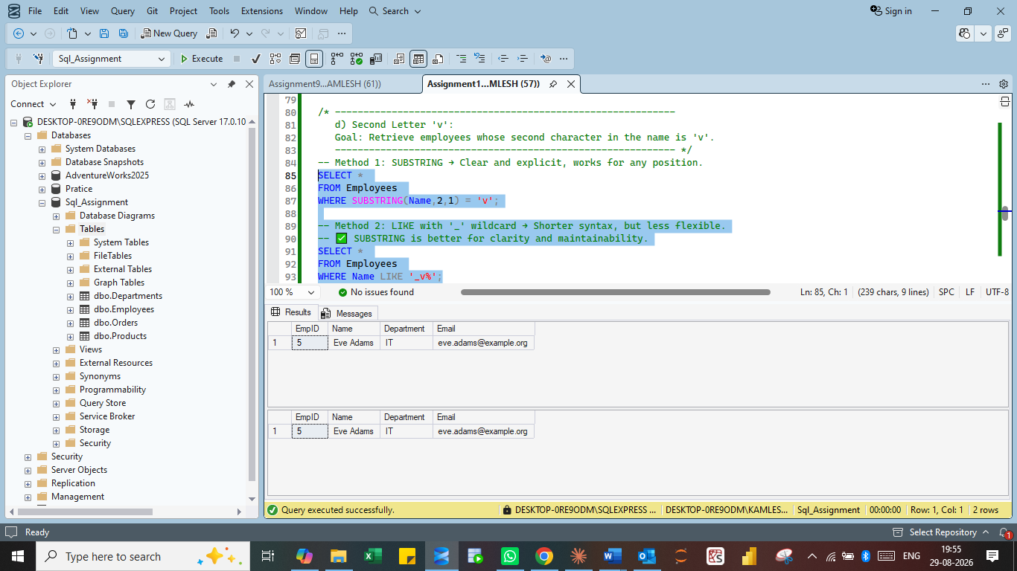

(e) Departments Containing 'IT'
Goal: Select employees whose department name contains the substring "IT".
Method 1 — LIKE
SELECT Name, Department
FROM Employees
WHERE Department LIKE '%IT%';
'%IT%' matches any department name that contains "IT" anywhere within it. Simple and widely understood.
Method 2 — CHARINDEX
SELECT Name, Department
FROM Employees
WHERE CHARINDEX('IT', Department) > 0;
CHARINDEX('IT', Department) returns the numeric starting position of "IT" within the Department string, or 0 if not found. Checking for a position greater than 0 confirms a match, and this function tends to perform better on large text fields.
✔ Recommended: CHARINDEX is preferable for substring searches over large text fields.
Output: screenshot_2e:
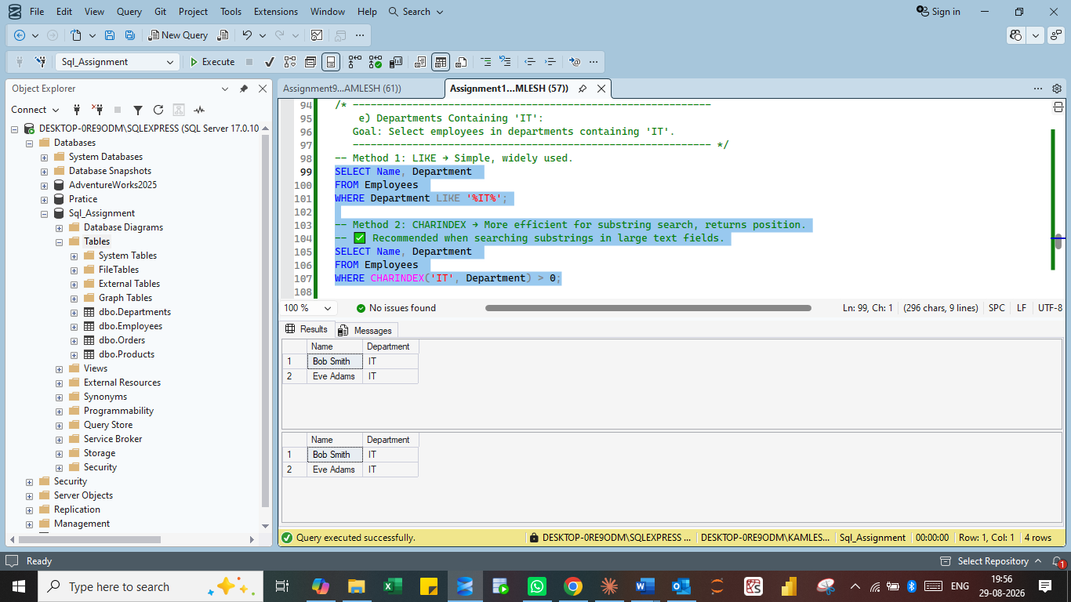

(f) Case-Insensitive Match for 'hr'
Goal: Find employees in departments containing "hr", regardless of letter case.
Method 1 — LOWER()
SELECT *
FROM Employees
WHERE LOWER(Department) LIKE '%hr%';
LOWER(Department) converts the department value to lowercase before comparing it against the lowercase pattern '%hr%', ensuring the match ignores case. This function is portable and works the same way across most database systems, though it does add a small amount of processing overhead.
Method 2 — COLLATE (case-insensitive collation)
SELECT *
FROM Employees
WHERE Department COLLATE SQL_Latin1_General_CP1_CI_AS LIKE '%hr%';
COLLATE SQL_Latin1_General_CP1_CI_AS temporarily applies a case-insensitive (CI) collation to the comparison, so the LIKE check ignores case without needing a function call on every row. This is a SQL Server–specific technique and is typically faster than LOWER().
✔ Recommended: COLLATE is faster in SQL Server since it avoids per-row function calls, but LOWER() is more portable across database platforms.
Output: screenshot_2f:
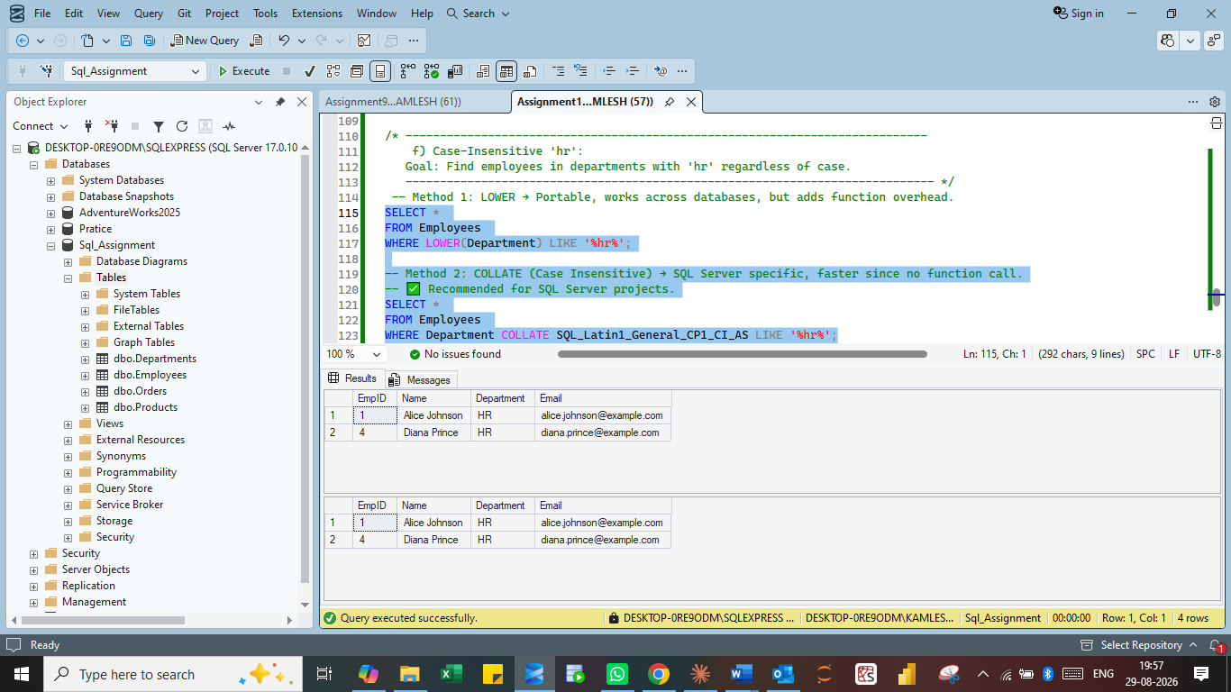

Summary
This project walked through six common text-search scenarios on an Employees table, each solved two different ways: using the flexible LIKE operator with wildcards, and using a more targeted string function (RIGHT, LEFT, SUBSTRING, CHARINDEX, or COLLATE). The general pattern that emerges is:
- LIKE is best for quick, readable, general-purpose pattern matching.
- Dedicated string functions (LEFT, RIGHT, SUBSTRING, CHARINDEX) are more precise and often more efficient when the position or length of the match is known.
- For case-insensitive searches, COLLATE is faster in SQL Server, while LOWER() is the more portable, cross-platform choice.
Understanding both approaches allows a developer to choose the right tool depending on whether the priority is readability, portability, or query performance.

